|  |  |  |  |  |  |
| --- | --- | --- | --- | --- | --- |
| Date | 2-Dec-22 | | | Tester Name | Richard Belanger |
| Environment | Penfax - Test | | | Login used | TEST2 |
| Operating System | Windows | Version: | Update: | | |
| Software Used | Edge | Version: | Update: | | |
| Not Applicable | Version: | Update: | | |
| Release version | 22.4.1 | | | | |
| Title | M9.04 Designated member make payment date greater than 120 days of termination | | | | |
| Test Type | Regression | | | | |
| Test Scenario | Terminate member and make payment date greater than 120 days of termination | | | | |
|  |  | | | | |
| Expected Results | The member will be terminated paid out with correct taxes taken | | | | |
| Pass/Fail | Pass | | | JIRA# | N/A |

Describe your steps with screenshots:

Member is Designated, Deferred and termination date greater than 120 days

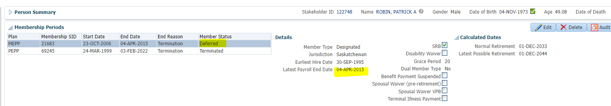

Benefit Calculation>Calculate

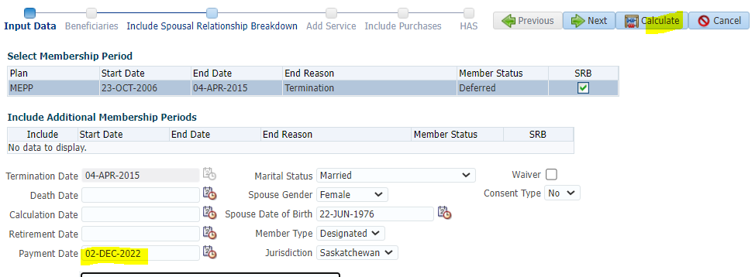

Process

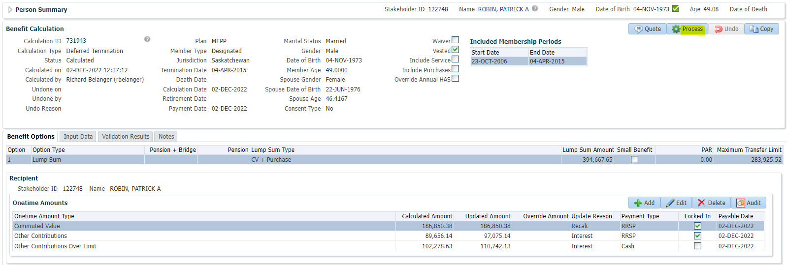

Processed>To Benefit Selection>Next

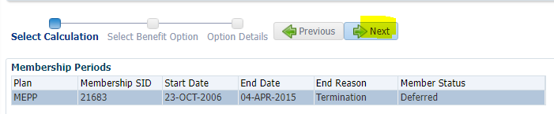

Next

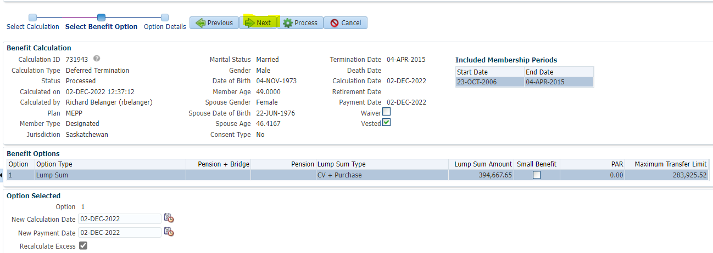

Payment Instructions added; Tax Instructions added>Process

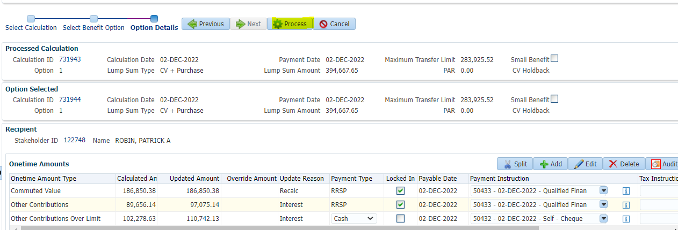

Member has Lump Sum Payment status

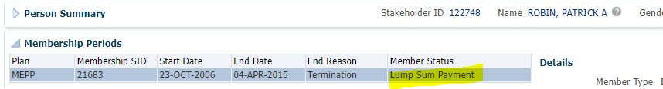

To Benefit Recipient>Onetime Amounts>Approve the payments

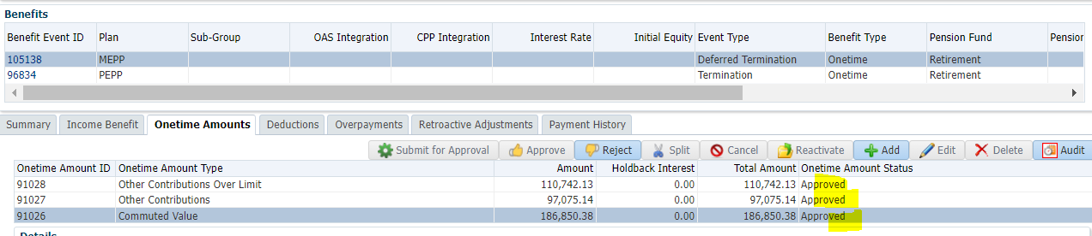

To Summary to Authorize>Authorized

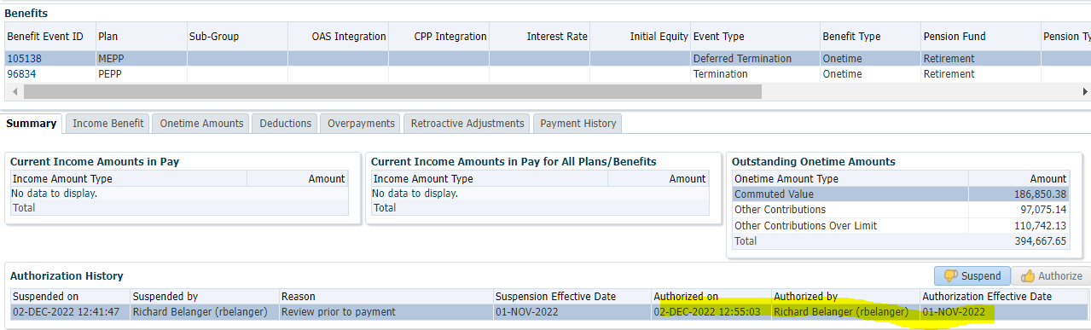

Payment batch produced payment

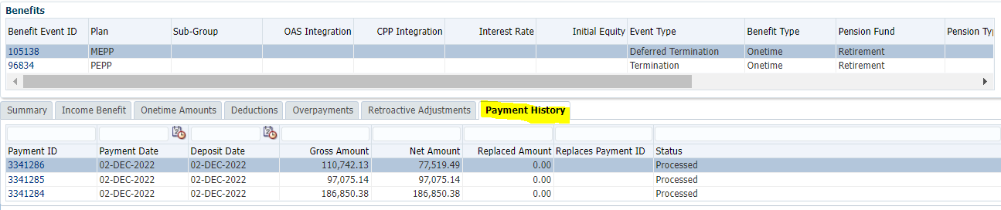

Tax Rates

0.00-4,999.99 = 10%

5,000.00- 14,999.99 = 20%

15,000.00+ = 30%

One Payment is for Cash, Total Tax taken will be the amount

So…110,742.13 x 30% = 33,222.64; 110,742.13 – 33,222.64 = $77,519.49

RRSP payments of 97,075.14 + 186,850.38 has no tax taken